GEF-6 Project Identification Form (PIF)
Project Type:
Type of Trust Fund:


For more information about GEF, visit TheGEF.org

PART I: Project Information
Project Title: | Myanmar Rural Renewable Energy Development Programme
Country(ies): | Myanmar | GEF Project ID: |  |  |  | 9890
GEF Agency(ies): |  | GEF Agency Project ID: |  |  |  | 5564
Other Executing Partner(s): | Department of Rural Development, Ministry of Agriculture, Livestock and Irrigation | Submission Date:  Re-submission Date: |  |  |  | 28 August 2017  25 September 2017
GEF Focal Area(s): |  | Project Duration (Months) |  |  |  | 60
Integrated Approach Pilot | IAP-Cities IAP-Commodities IAP-Food Security |  |  | Corporate Program: SGP
Name of parent program: | N/A |  | Agency Fee ($) |  | 468,752

A. indicative Focal Area Strategy Framework and Other Program Strategies
Objectives/Programs (Focal Areas, Integrated Approach Pilot, Corporate Programs) | Trust Fund | (in $)
 | Trust Fund | GEF Project Financing | Co-financing
CCM  Objective 1, Program 1: Promote the timely development, demonstration, and financing of low-carbon technologies and policies. |  | 4,934,228 | 33,000,000
Total Project Cost |  | 4,934,228 | 33,000,000

B. indicative Project description summary

Project Objective: To facilitate expansion of rural renewable energy services and productive applications in Myanmar

Project Components | Financing Type | Project Outcomes | Project Outputs | Trust Fund | (in $)
 |  |  |  |  | GEF Project Financing | Co-financing
1: Policy and regulatory de-risking for improved renewable energy (RE) services and productive application |  | - Effective implementation of supportive policies for enhanced RE utilisation in rural productive uses. | 1.1 Conducting DREI (Derisking Renewable Energy Investment) analysis to identify risks and barriers for coordinated design of policy and financial derisking instruments to support the implementation of the National Electrification Plan (NEP) in rural areas and producing a DREI Study for small scale RE in Myanmar.  1.2 Feasilibilty analysis of policy tools and incentives for promoting rural RE planning and investments completed  1.3 Toolkit of procedures for planning and developing rural renewable energy at state and township level developed and operational  1.4 Inclusion of productive uses of RE applications in national and state level rural livelihoods policies for key livelihood sectors in rural areas  1.5 Technical assistance to Rural RE Focal Point to coordinate and facilitate project implementation and cooperation among various market actors as well as ongoing and planned projects and programmes on RE |  | 369,746 | 1,955,800
2: Strengthened capacity and awareness for market enablers on rural renewable energy application |  | 2. Strengthened market demand for affordable RE technologies for rural livelihoods application | 2.1 Capacity needs assessment conducted for various market actors including policymakers, local government, project developers.  2.2 Technical guidelines and reference handbook on design, financing, installation and operation of rural RE for techicians and developers developed and disseminated  2.3 Developed and completed trainings for village electricity committees and community representatives on various aspects of rural RE including planning, management, monitoring, operations, maintenance and partnerships: 4 trainings per year per state, 30 to 50 participants per training. In total 960 to 1600 people receiving training. Each training will have 5 participants that will receive extra “train the trainer” education (80 trainers per state).  2.4 Developed and completed trainings for RE developers, installers and service providers on technical, financing and management: 3 trainings per year, 30 to 50 participants per training. In total 360 to 600 people receiving training.  2.5 Designed and delivered training programme on standard compliance and quality certification for installers and services providers, facilitated by Ministry of Education: 3 trainings per year, 30 participants per training. In total 360 to 600 people receiving training.  2.6 Developed and executed multi-media awareness campaigns on RE and productive uses  2.7 Documented experiences and lessons on RE applications on rural livelihoods applications (including technical assistance for strengthening REAM knowledge sharing activities provided)  2.8 DRD RE focal point and Ministry of Education technicians trained in RE technology testing and quality monitoring |  | 869,773 | 3,802,100
 | INV |  | 2.9 RE technology testing facility hosted by Ministry of Education established, staffed, equipped and operational. | GEF TF | 1,000,000 | 2,000,000
3: Rural renewable energy financial de-risking through Financial Support Mechanism | TA | 3. Increased investments in rural RE for productive uses and enterprise development | 3.1 Completed RE resource assessments  3.2 Completed assessment of productive activities and their energy demand levels  3.3 Completed assessments on RE sector financial services and products demand and on financial support mechanism partners selected and design  3.4 Formulated and demonstrated modalities  for Public-Private-Partnerships (PPP) are put in place  3.5 Designed and delivered capacity  development trainings for financial support mechansim and services to promote RE investment, evaluate cost benefit, risks associated with RE projects  3.6 Operational RE systems with total installed capacity at least 15 MW for communities(e.g. solar, wind power, micro and mini-hydro and waste-to-energy) |  | 959,746 | 13,592,100
 | INV |  | 3.7 An appropriate financial support mechanism, if found to be necessary (during the PPG) will be designed and put in place. |  | 1,500,000 | 10,000,000
Subtotal |  |  |  |  | 4,699,265 | 31,350,000
Project Management Cost (PMC) |  |  |  |  | 234,963 | 1,650,000
Total Project Cost |  |  |  |  | 4,934,228 | 33,000,000

C. Indicative sources of Co-financing for the project by name and by type, if available
Sources of Co-financing | Name of Co-financier | Type of Co-financing | Amount ($)
Recipient Government | Department of Rural Development, Ministry of Agriculture, Livestock and Irrigation | Cash | 10,000,000
Recipient Government | Department of Rural Development, Ministry of Agriculture, Livestock and Irrigation | In-kind | 14,300,000
GEF Agency | UNDP | In-kind | 200,000
Government Agency | Department of Research and Innovation, Ministry of Education | In-kind | 3,000,000
Private sector | TBD | Cash | 5,500,000
Total Co-financing |  |  | 33,000,000

D. Indicative Trust Fund Resources Requested by Agency(ies), Country(ies), Focal Area and the Programming of Funds ^{a)}
GEF Agency | Trust Fund | Country/  Regional/ Global | Focal Area | Programming  of Funds | (in $)
 |  |  |  |  | GEF Project Financing (a) | Agency Fee (b)^{b)} | Total  (c)=a+b
 |  | Myanmar |  |  | 4,934,228 | 468,752 | 5,402,980
Total GEF Resources |  |  |  |  | 4,934,228 | 468,752 | 5,402,980
- Refer to the Fee Policy for GEF Partner Agencies.

E. Project preparation grant (ppg)
Is Project Preparation Grant requested? Yes No If no, skip item E.

PPG Amount requested by agency(ies), Trust Fund, country(ies) and the Programming of funds
Project Preparation Grant amount requested: $100,000 PPG Agency Fee: $ 9,500
GEF Agency | Trust Fund | Country/  Regional/Global | Focal Area | Programming  of Funds | (in $)
 |  |  |  |  | PPG (a) | Agency  Fee (b) | Total  c = a + b
 |  | Republic of Belarus |  |  | 100,000 | 9,500 | 109,500
Total PPG Amount |  |  |  |  | 100,000 | 9,500 | 109,500

F. Project’s Target Contributions to Global Environmental Benefits
Provide the expected project targets as appropriate.
Corporate Results | Replenishment Targets | Project Targets
- Maintain globally significant biodiversity and the ecosystem goods and services that it provides to society | Improved management of landscapes and seascapes covering 300 million hectares | Hectares
- Sustainable land management in production systems (agriculture, rangelands, and forest landscapes) | 120 million hectares under sustainable land management | Hectares
- Promotion of collective management of transboundary water systems and implementation of the full range of policy, legal, and institutional reforms and investments contributing to sustainable use and maintenance of ecosystem services | Water-food-ecosystems security and conjunctive management of surface and groundwater in at least 10 freshwater basins; | Number of freshwater basins
 | 20% of globally over-exploited fisheries (by volume) moved to more sustainable levels | Percent of fisheries, by volume
- 4. Support to transformational shifts towards a low-emission and resilient development path | 750 million tons of CO_{2e} mitigated (include both direct and indirect) | Direct: 224,192 metric tons  Indirect: 672,576 metric tons
- Increase in phase-out, disposal and reduction of releases of POPs, ODS, mercury and other chemicals of global concern | Disposal of 80,000 tons of POPs (PCB, obsolete pesticides) | metric tons
 | Reduction of 1000 tons of Mercury | metric tons
 | Phase-out of 303.44 tons of ODP (HCFC) | ODP tons
- Enhance capacity of countries to implement MEAs (multilateral environmental agreements) and mainstream into national and sub-national policy, planning financial and legal frameworks | Development and sectoral planning frameworks integrate measurable targets drawn from the MEAs in at least 10 countries | Number of Countries:
 | Functional environmental information systems are established to support decision-making in at least 10 countries | Number of Countries:

part ii: project JustiFication

- Project Description. Briefly describe: 1) the global environmental and/or adaptation problems, root causes and barriers that need to be addressed; 2) the baseline scenario or any associated baseline projects, 3) the proposed alternative scenario, GEF focal area strategies, with a brief description of expected outcomes and components of the project, 4) incremental/additional cost reasoning and expected contributions from the baseline, the GEFTF, LDCF, SCCF, CBIT and co-financing; 5) global environmental benefits (GEFTF) and/or adaptation benefits (LDCF/SCCF); and 6) innovation, sustainability and potential for scaling up.

A.1.1 Global environmental problems, root causes and barriers that need to be addressed

- Low levels of access to modern energy services negatively impact on social and economic development in Myanmar. Currently, only about 33% of the Myanmar population have access to electricity (World Bank, 2014) and over 90% of households depend on solid biomass for cooking. The energy access situation is worse in rural areas where 70% of the Myanmar population live but less than 16% of the households have access to electricity compared to urban areas such as Yangon and Nay Pyi Taw where over 50% of households have electricity (ADB, 2013). Lowest electricity access levels are in Rakhine state and Tanintharyi region with household electricity access at 6% and 9% respectively (Myo Aung San, 2012). Although renewable energy (RE) – mostly hydropower – comprises about 76% of the energy generated in Myanmar, much of this is large-scale RE that supplies centralised national grid but most rural areas remain unelectrified. Where electricity is available in rural areas, much of it is generated from expensive fossil fuels – mostly diesel - despite Myanmar having over 100GW potential for renewable energy. Trends in rural electrification since 2012 show that when villages are electrified, an average of 55% of them are electrified using diesel generators (DRD, 2015). The dependence on diesel-generated electricity for the few in rural areas that have access to electricity means high energy costs to households and enterprises yet most of the energy is limited to 2 to 3 hours per day (GoRUM, 2015). Thus even where there is electricity access in rural areas, it is unlikely to be used for productive uses given its short daily availability. Rural residents without electricity depend on dry cells (batteries), kerosene, candles and firewood for their energy needs at a high economic, environmental and social (health and gender) costs.

- The high economic costs of energy in rural areas mean that poor rural women and men spend more – both in absolute price terms and in proportion of incomes –for poor quality energy services which constrains their achievement of social and economic goals and negatively impacts environmental integrity. For example, the ADB Scoping study (2014) found that households depending on candles and batteries for lighting spent between US$2.75 and US$5.45 a month on lighting, those using diesel spent between US$2.7 and US$5.40 per month. Meanwhile, off-grid customers pay between 11.7USc/kWh and 35.2USc/kWh compared 4.1USc/kWh paid by grid customers, 8.8USc/kWh for industry and 12USc/kWh for foreigners (Zaw Moe Win, 2013). The productivity and profitability of rural enterprises and livelihoods is therefore constrained due to such low availability, reliability and high costs of energy.

- Although the government is planning more power stations, supply deficits are still expected, especially in rural areas. Myanmar is experiencing rapid economic growth, averaging 6% per annum between 2010 and 2014 (World Bank database, 2015), resulting in an increase in demand for modern energy supply. Supply deficit and high system losses of up to 21% mean that existing and new centralized capacity will likely prioritise the profitable industrial sector and urban areas rather than new rural electrification. This is in part reflected in the National Electrification Plan (NEP) in which grid electrification is allocated 3.75 times the amount of financing allocated to off-grid electrification.

- From a national and global environmental perspective, the high dependence on diesel-generated electricity and traditional biomass increases the country’s contribution to global GHG emissions. The energy sector in Myanmar, although the third largest emitter after the agricultural sector and land use changes, is the only one of these top three sectors where emissions are growing, increasing by 120.5% between 2009 and 2011 while the emissions in the two other largest emitting sectors, agriculture and land use, decreased over the same period (WRI, 2012). GHG emissions related to energy access mainly include direct emissions from fossil use and black carbon from cooking but also the removal of carbon sinks when natural forests are harvested for firewood and charcoal. The Myanmar energy sector therefore contributes to sustainable development challenges that are a direct result of lack of access to modern and sustainable energy. Increasing access to RE could help resolve these challenges and their impacts. However, use of RE in rural areas is low due to a number of barriers and their root causes as outlined below:

Low market confidence
- Market confidence is low among would-be investors in the Myanmar rural RE market. The root cause of this is policy uncertainty since the RE policy is yet to be formulated. There are no RE targets, pricing, planning and permiting processes are unclear, and there are no standardised processes such as standard power purchase agreements. In addition, for the rural RE market, investors who undertake market analysis conclude that there are large numbers of households who will have great difficulty to pay whereas if they target the industrial and commercial market then this is much less of an issue. Consequently, in Myanmar the private sector market does not work properly when it comes to financing small scale off grid RE projects.

- This sector-specific uncertainty is compounded by uncertainty due to ongoing governance reforms. In addition, the structure of energy sector in Myanmar is very fragmented as shown in Table 1 below. This results in poor coordination of energy-related activities which exercerbates lack of confidence in energy planning processes. The following table explains the responsibilities of various Ministries in Myanmar regarding development of policies and legislation in the energy sector.

- Table 1: Responsibilities for various aspects of energy development in Myanmar
Ministry | Responsibility
Ministry of Electricity and Energy | Hydropower and thermal power plants, and transmission and distribution; Oil and gas.
Department of Rural Development (DRD), Ministry of Agriculture, Livestock and Irrigation | Biofuels and microhydro for irrigation purposes {Hydropower (<10 MW)}  Rural electrification works through renewable energy sources.  Promotion of productive activities in rural areas
Department of Research and Innovation, Ministry of Education | Research and development of renewable energy technologies
Ministry of Natural Resources and Environmental Conservation | Biomass environmental and climate change issues; Coal extraction.

- One example of the fragmented nature of the sector and how it is confusing to would-be developers is thatwhile there is a Ministry of Electricity and Energy, it is the Ministry of Education that has been tasked with leading the formulation of a Renewable Energy Policy. It also undertakes some RE training and monitoring. Yet if the developer is focused on rural energy and if the installation is a microhydro, under 10MW aimed at irrigation, or if investments relate to biofuels, then it is the Ministry of Agriculture, Livestock and Irrigation which is responsible for rural electrification through its Department for Rural Development (DRD). The Department of Rural Development then undertakes its own monitoring of its installations. Those wanting to generate energy from plantation crops would have to approach the Ministry of Natural Resources and Environmental Conservation responsible for forestry including plantations. Environmental Conservation Department under the Ministry of Natural Resources and Environmental Conservation is thereby involved in monitoring and reporting the greenhouse gas emission reductions from sustainable energy development in Myanmar. This means one has to approach ministries for different aspects of project development and depending on their size, RE resource, spatial focus and other parameters. It then gets confusing for developers to navigate through such fragmentated, time consuming procedures, leading to increased project lead times and costs. The NEP as it stands does not provide for a specific coordinating agency or focal point for rural electrification although problems with coordinating a highly fragmented energy sector are acknowledged by many actors in the sector.

Policy, planning and regulatory barriers

- The NEP and its attendant investment prospectus provide broad roadmaps on how to reach universal access to sustainable energy in Myanmar in terms of the number of connections that must be achieved every year to reach universal access and their costs but as yet provides no policy implementation tools such as guidelines for rural RE planning, standardized procedures, incentives for market actors such as the private sector and CSOs or quality framework specific to rural RE, whether for products or for services. Additionally, the current frameworks do not specifically address RE affordability and poverty of rural residents so that RE deployment is unlikely to stimulate economic productivity, reduce poverty or improve women’s empowerment and social inclusion. This risks the use of traditional approaches to national electrification that do not specifically address issues of affordability, or clarify processes for participation of various market actors. There is no streamlined permiting processes and each developer has to negotiate permits individually. Similarly there is a lack of standard power purchase agreement or feed-in-tarrifs which creates pricing uncertainties. Thus tarrifs have to be negotiated on case by case basis which is time consuming and creates a sense of lack of transparency. For small scale RE developers, accessing expertise for permits and tariff negotiations is costly that’s deterring their participation in the RE sector.

- Poorly designed subsidies are another barrier to the growth of the RE market in Myanmar. So far, the Government of Myanmar provides 100% subsidies to RE technologies such as Solar Home Systems deployed for its rural electrification programme but there is little provision for quality control or maintenance. Subsidies act as a barrier to market growth in three key ways. First, it deters RE developers that cannot access such subsidies as it makes them uncompetitive. Secondly, they reduce the sense of ownership from the consumer side which experience globally has shown results in high failure rates of RE initiatives. Finally, free or 100% subsidised RE technologiess are a huge cost to government which is likely to slow down electrification efforts as the programme expands to reach universal access and old sytems must be replaced. Already, the quality of subsidized SHS is compromised due to cost caps imposed to maximize the subsidy funds and set at 200,000 kyat (US$160) per installed SHS so that companies contracted to install systems under the government programme either compromise on quality or struggle to cover costs (Graecen, 2015).

11. One of the principal challenges for scaling-up RES in developing countries like Myanmar is to lower the financing costs that affect renewables’ competitiveness against baseline technologies – i.e. primarily fossil fuels (UNDP, 2013). As these higher financing costs reflect barriers and associated risks in the investment environment, the key entry point for policy-makers in Myanmar to promote RES is to address these risks and thereby lower the overall life-cycle generation costs of RES. The barriers idenitifed above act as drivers of investor risk and should therefore be part of the analysis of possible de-risking approaches in order to reduce the cost of capital for renewable energy projects.

Limited capacity and information

12. Limited capacity and information is another barrier that the Myanmar energy sector faces which deters the development and use of RE in rural areas. Myanmar as with many developing countries, lacks capacity in various aspects of RE development including knowledge and skills in policy formulation, implementation and enforcement of market-stimulating policies and regulation; tender specifications, construction, maintenance and services provision for rural RE. The root cause of the capacity barrier is decades of isolation from the international community and limited involvement of CSOs and the private sector in the energy and other sectors which has limited knowledge transfer. In consulations with Ministry of Education, the ministry indicated that there is some basic training on RE technologies but these need to be updated and that there is need for advanced training to further improve the skills of technical personnel that undergo their basic training programme. Graecen (2015) found many SHS have poor and hazardous wiring, while Kumara (2015) found poor quality installations including wide voltage and frequency variations and that other quality-controlling components were not in use (e.g. controllers, lack of speed matching, poor bearing selection) in microhydro installations. The Ministry of Education also indicated that their staff lack capacity to effectively monitor RE initiatives in the country such that results of RE initiatives are poorly understood and not shared, and poor quality RE technologies are widely used because of lack of capacity to test, identify and recommend or approve good quality RE technlogies. DRD also lacks the capacity to identify quality RE technologies even for its own programme (Graecen, 2015). Such lack of capacity results in high levels of project failure (Graecen, 2015; Kumara, 2015).

- The lack of knowledge and skills contributes to poor availability of data and high levels of inaccuracies and inconsistencies in the available data which affects both the developers’ and consumers. Unavailable, inaccurate and inconsistent data makes the development of RE resources expensive for developers while consumers lack quality and reliable data to make informed choices in purchasing or using RE technologies. This is worsened by lack of experiences in using RE technologies. While RE technologies are slowly making inroads into the market, poor quality RE technologies are common and result in low consumer and policy-makers’ confidence thus stunting RE market growth. During consultations, some policy makers expressed reluctance to support biomass gasifiers because they are seen as polluting both air and waterways. This reluctance is based on consumers’ resistance to biomass gasifiers in areas such as Laputta township where rice husk gasifiers are said to have polluted air and waterways. Pollution problems have also been reported in Rakhine (Shwe Gaung, 2013) and other states. However, pollution is not an inherent feature of biomass or rice gasisifiers but symptomatic lack of technical capacity to construct and manage them. With appropriate technical know-how and good technology management skills, biomass including rice husks gasifiers are a clean energy technology that also address the waste management of rice husks which, if not used in gasifiers, are often dumped unprocessed in rivers (REAM, 2013). Similarly, due to lack of experience with sustainable business models for rural energy access, some policy makers were reluctant to support market-based models of rural RE access, citing high levels of poverty in rural areas. In rural areas where grid electrification has not reached, some villages have depended on the self-reliant electrification (SRE) approach whereby villagers mobilise funds within the village to provide energy access themselves. This approach is retarded by lack of technical expertise, lack of skills and guidelines on governance and management of electrification committees, and in some cases poor social cohesion and overreliance on social capital (connections) to link to local government authorities (World Bank, 2015).

- While there are a number of capacity building efforts (e.g. technician training by Ministry of Education) ongoing in Myanmar, there remain gaps in capacity building support. Much of the capacity building in the RE sector has been at a basic level, such as that offered by the Ministry of Education to technicians. International agencies such as JICA have recently provided some capacity building such as during the development of the Energy Master Plan but more capacity building is needed for intermediate and advanced technical skills. In addition, there is as yet no systematic knowledge management approach so that learning of lessons and sharing of information is chaotic. The Renewable Energy Association of Myanmar (REAM) does conduct some research but this is not always available in a user-friendly form or widely available. Similarly the information of RE initiatives and experiences from the various ministries and agencies implementing some RE initiatives is difficult to find and often not documented at all. Neither is there adequate sharing of townships and states’ experiences of self-reliant electrification initiatives. Further, banks being relatively unaware of best and emerging practices in energy financing and the Myanmar RE market, lack the capacity to effectively assess risks and opportunities in the sector. Without the GEF project these gaps in capacity and lack of effective knowledge management and sharing will continue and lessons from emerging experiences will be lost.

Lack of affordable finance for developers and users
- Another key barrier to renewable energy investments and use is lack of affordable finance which is rooted in lack of market maturity of both the rural renewable energy and financial markets. Both RE and financial markets are relatively new in Myanmar. Investments in RE in rural Myanmar are currently low due to high risk perception, low awareness of returns and other benefits of RE, and lack of risk-mitigation instruments and investment incentives. There are no dedicated financial instruments for RE development other than small, project-based microloans for pico RE products. In addition, many local project developers do not have the necessary capital and/or assets and/or track record to be able to successfully obtain project financing. With dependence on 100% subsidies, there is no critical mass of RE investments with proven economic viability in rural area. Moreover, because many SRE initiatives have insufficient funds and limited access to financing, they often provide poor quality and low levels of electricity (1-2 bulbs for 2 hours a day). This is insufficient to support productive uses and hence poverty reduction. On the financial market side, the banking sector was opened up in 1992 after being nationalized in 1962 but restrictive regulations have stunted the maturity of the financial sector. The banking sector is largely focused on lending to the commercial/industrial sector and not to the rural communities.

- The World Bank Investment Climate Assessment for Myanmar rates lack of access to finance as the main barrier to doing business in the country (World Bank/IFC, 2015). There are currently (May, 2015) about only 11 private banks and 9 state and semi-state banks as well as representatives from a number of international banks. For investors, lack of finance is reflected in that bank borrowing finances only 1% of fixed assets while 92% of enterprises depend on their own financing (World Bank/IFC, 2015). Bank loans make up only 19% of the GDP compared to Cambodia where they are 108% of GDP or Vietnam where it is 36% (PwC, 2014) reflecting high dependence on own finance or other sources of borrowing which are often risky and of high interest rates. Only 4.5%. 15.% and 22.8% of small, medium and large firms respectively, have access to finance in Myanmar (Ayyagari and Beck, 2015). For most banks, maximum loan period is 1 year and high collateral of between 40% and 200% of the loan value is required with restrictive collateral requirements. Such conditions are not conducive for accessing finance for rural RE developments.There is no RE-specific financing for RE developers and many financial institutions are unaware of the risks and opportunities in the Myanmar RE market and are therefore risk-averse and opportunity-blind. This is worsened by lack of incentives and risk-reduction mechanisms such as on-lending support to banks to reduce the cost of finance and lending to the rural RE sector.

- For consumers, there is an acute lack of microfinance. The root cause of this is that Myanmar has historically not had microfinance institutions. The main microfinance scheme started in 1997 under a UNDP project and was limited to the (Irrawaddy) Delta, the Dry Zone and Shan State. NGOs such as PACT, GRET, World Vision and Proximity have implemented mifrofinance initiatives but only since the 1990s. The lack of microfinance is reflected in that demand for microfinance is estimated to be four times the current supply (IFC/CGAP, 2013) so that less than 20% of those in need of microfinance are actually served. Few initiatives including by PACT, Proximity Designs, Mercy Corps, and Total Solar provide some microfinance for the RE products that they promote which are solar lanterns, SHS and cookstoves.

Undemonstrated economic viability of rural RE
- There are a number of RE companies in Myanmar, many of which have emerged since the reforms and opening up of the country in 2011 and therefore most of these companies are relatively inexperienced and lack easy access to capital and expertise. In terms of operations and economic viability, local RE companies in Myanmar are largely dependent on implementing highly subsidized government projects or projects with donor grant finance. This is not a long term sustainable solution for market development. As such, the economic viability of rural RE investments remains largely undemonstrated.

A.1.2 The baseline scenario and baseline project
19. The Government of the Union of Myanmar recognizes the unique problems faced by its rural population and has drawn up the National Rural Development and Poverty Plan Among a list of eight tasks, are two that directly link to this project (1) increasing rural productivity and (2) increasing the use of RE although these are not explicitly linked. Currently, about 76% of installed capacity is hydropower. However for off-grid, 63MW (63.5%) is diesel-based, while mini-hydros provide 33.02MW and biomass provide 3.72MW (Zaw Moe Win, 2013). Solar home systems have also been widely implemented but many of these suffer from poor quality of systems and installation techniques (Graecen, 2015). Microhydro installations are also often of poor quality with little or no load control among other problems (Kumara, 2015).

20. The Myanmar government has formulated the National Electrification Plan (NEP) with the aim of reaching universal sustainable energy access by 2030. Futher, a Power Master Plan and an Electricity Master Plan have been formulated. Under the NEP scenario, the contribution of coal to electricity generation capacity will increase from the current 8% to about 33% such that by 2030 over 7,785MW out of 23,594MW will be coal-based generation which will triple the amount of CO₂ emitted from coal-based generation. Hydropower development will continue to be large scale, impacting on sensitive ecosystems such as the Salwein river. The decision to continue large scale hydropower projects that require large scale dams has already generated protests such as those against the development of a Mong Ton hydropower dam project on Salwein (Thanlwin) River and Palet Wa Region. There have also been protests against coal power stations at grassroots level in Mon State in May 2015 and nationally and internationally by environmental, RE and human rights advocates. As such developments such as the Salwein river are being postponed. Such protests could further delay reaching universal electrification in 2030.

21. Currently, some 67% of the population in Myanmar (over 30 million people) have no access to electricity. At the current rate of new connections which stand at about 189,000 per annum, the World Bank estimates that it will take Myanmar 40 years to reach universal energy access. The NEP will require an average of 450,000 new connections per year to reach a target of 7.2 million new households by 2030, over twice the current rate of new connections per annum. Achieving universal energy access will require US$16 billion between 2014 and 2030. The first phase for five years alone (2016-17 to 2020-21 ) targets 1.7 million new electricity connections that will at about $700 million in investments. Such investments will require mobilising resources – financial, technical, human and otherwise - from the public and private sectors. The World Bank support to the first phase of NEP currently provides about US$400 milliontargeting 1.2 million households, with US$80 million targeting off-grid connections. According to the World Bank, the latter will support 456,000 households with Solar PV connections and 33,500 households through mini-grids. In addition 11,400 clinics will be provided with energy access and 19,000 street lights will be supported. Thus there still remains a gap in action and financing in order to reach universal access to energy by 2030 given that 45,258 villages (approximately 7 million households) are currently without electricity access. Even with the World Bank support, a deficit of US$300 million will remain to achieve the phase one target required for the period 2016-17 to 2020-21. At current electrification rates, it is unlikely that this target will be met and energy access and povery reduction targets may not be met.

22. This GEF project will address investment barriers including risk aversion and lack of capacity by clarifying policies and procedures, demonstrating the economic viability of RE investments, supporting access to finance, reducing risk aversion by financial institutions, and overall, creating an environment for mobilizing resources from development partners, government, the private sector and households, and for utilizing RE for productive applications in rural areas. The GEF project will contribute to the meeting of the objectives of the NEP in rural areas where decentralized energy systems can play an important role in rural social and economic development and will support environmental goals. In addressing the productive uses of energy, the GEF project will also ensure sustainability of RE initiatives by promoting the use of sustainable energy to improve productivity in rural areas which will in turn improve economic standing of the population and their capacity to pay for energy use. The use of public-private partnerships (PPPs), including converting SREs to PPPs will ensure supportive environment for communities as well as increased sense of ownership. Morever in some cases, communities could earn incomes from co-ownership of RE installations which can be reinvested in community initiatives.

23. The project will create synergies to the work being undertaken by the Ministry of Industry, the Ministry of Agriculture, Livestock and Irrigation, Department of Rural Development , development partners, NGOs, private sector and others to ensure cost-effectiveness and efficiency. Additionally, the project will make use of co-funding possibilities with on-going rural energy activities.

24. The baseline projects include the following:

Table 2: Baseline Projects which would take place in Myanmar without the GEF Project (Part I):

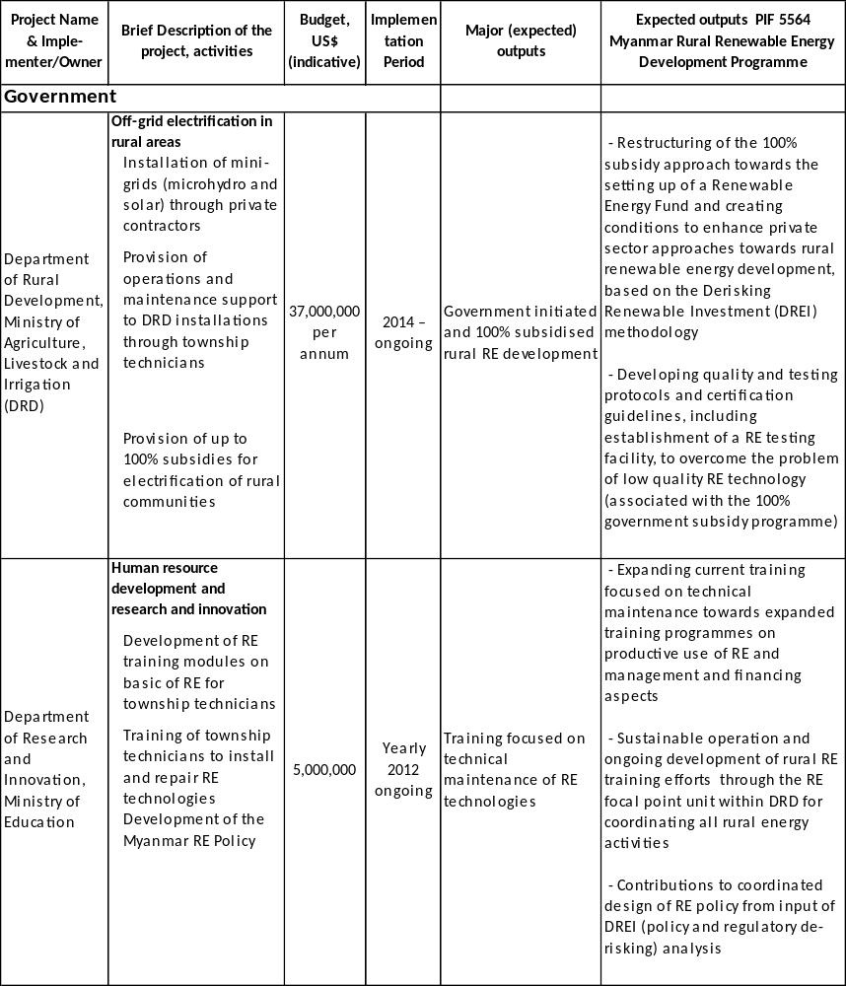

Table 2: Baseline Projects which would take place in Myanmar without the GEF Project (Part II):
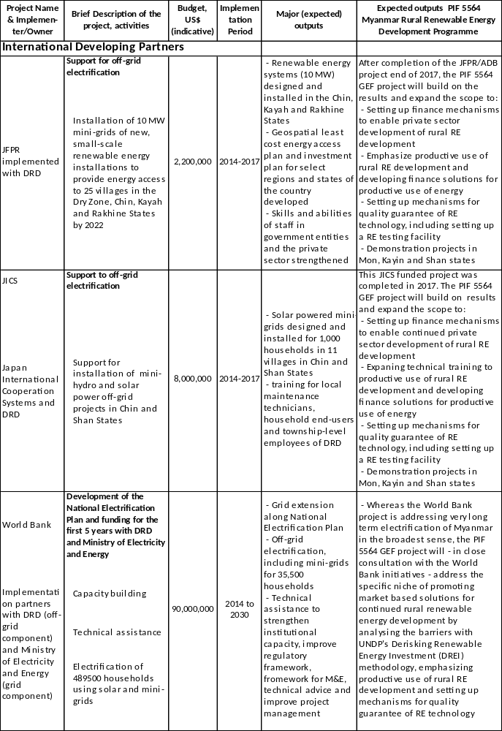

Table 2: Baseline Projects which would take place in Myanmar without the GEF Project (Part III):
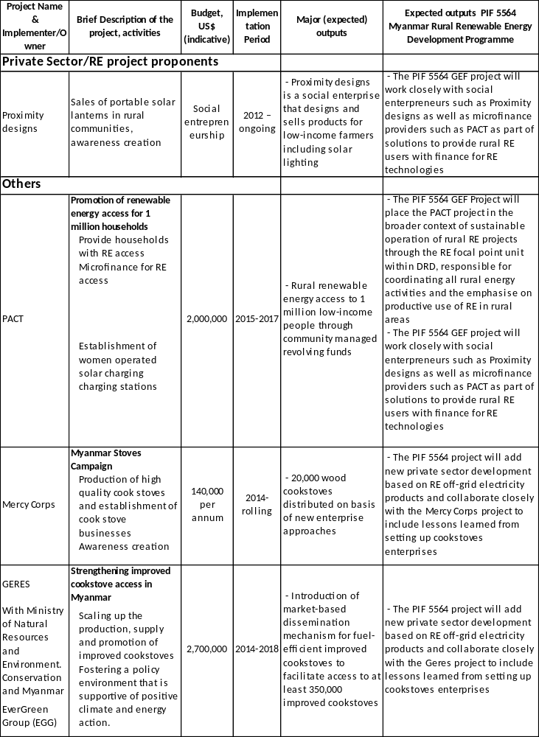

25. The GEF project will evaluate the results of these baseline projects, drawing lessons from its implementation and promote its replication as far as possible.

A.1.3 GEF alternative scenario and project:

26. The specific objective of the project with GEF support is to facilitate expansion of rural RE services coupled with productive application by providing technical assistance for both policy and financing de-risking. The project will target rural households, enterprises, clinics and schools as endusers while working across the sector to create an environment for market enablers, namely policy makers and planners at national and local levels, project developers, technical and financial services providers, township and village rural electrification committees, and energy end users. The project will reduce barriers to use of RE in rural areas by developing tools and incentives for effective policy implementation, and through capacity building and knowledge management, and promotion of financing and investments in rural renewable energies. Using UNDP’s Derisking Renewable Energy Investment (DREI) methodology, risk categories can be analysed for their contribution to the cost of capital for renewable energy development in order to then select the most cost-effective government measures to address these risks and to attract investment (UNDP, 2013). The full DREI methodology, including LCOE modelling, can be used at the PPG design phase and throughout project implementation, including – in order to monitor the impact of the project’s interventions – at mid-term and terminal evaluations. Demonstration projects and local level capacity building will be implemented in Mon, Kayin and Shan States while all other activities will be implemented at national level. The project will deliver its outcomes and outputs through the following three components:
Component 1: Policy and regulatory De-Risking for improved renewable energy services and productive application
27. Myanmar has developed its National Electrification Plan (NEP) in 2015, an investment prospectus (2015), Rural Electrification Law drafted in 2014 and is in the process of developing a Renewable Energy Policy. The existence of the NEP and the ongoing development of the Renewable Energy Policy represents a baseline situation and this project will develop the tools and necessary environment to support their implementation in rural areas and will improve overall coordination to ensure effective implementation of off-grid initiatives. As such Component 1 will comprise a combination of baseline and GEF incremental activities. The GEF project activities will focus on policy and regulatory de-risking and act in such a manner as to operationalise NEP’s rural electrification and off-grid commitments through the following indicative activities:
- Conducting the DREI analysis to identify risks and barriers and quantification of risk categories in order to provide the financial and economic basis for cost-effective and coordinated design of policy and financial derisking instruments for Myanmar to support the implementation of the NEP in rural areas.
- conducting feasibility analysis of tools, incentives and best practices for rural RE policy, planning and investments
- developing procedures and tools for the accelerated development of rural RE sector for use by policymakers and project developers at state and township levels.
- developing local level policy and planning guidelines on productive uses of RE
- lobby for and support the mainstreaming of RE for productive uses in rural development strategies and policies
- developing and disseminating rural RE planning and implementations guidelines and procedures on pricing and permits for small scale RE developers including Standardised Power Purchase Agreements for Small Scale Power Producers.
- designing appropriate incentives for project developers and other actors such as low interest loans to support public and private sector participation in rural RE access.
- ensure sustainable operation of the RE focal point unit within DRD for coordinating all rural energy activities. This will ensure that a well-capacitated focal point is in place to coordinate activities, provide leadership in rural RE access and avoid duplication of efforts. The focal point will ensure that processes such as permitting are clarified and that the information required for RE development, such as RE resource information is available in a “one-stop shop” manner at national, state/regional and township levels. The focal point will address the current fragmentation of responsibilities in the energy sector and will manage the GEF project, including co-financing, calls for proposals, development of database for developers among other tasks.
- support the development of guidelines for establishing, planning and managing public-private RE initiatives and self-reliant electrification (whereby villagers mobilise funds within the village to provide energy access themselves, see page 8), including support managing township and village electrification committees, and guidelines for converting self-reliant electrification initiatives into sustainable public-private RE models (and establishing new public-private partnerships for RE access where self-reliant initiatives do not exist) that will improve the economic sustainability of the initiatives. This will ensure improved governance of energy access initiative at local government level.
- support the development of a quality framework including quality and testing protocols, benchmarks and certification guidelines for products and services in the RE market (See Component 2). These will be used in tandem with planning guidelines and procedures and disseminated at national and local level.
28. Without this GEF project, uncertainty in the sector over RE planning and development procedures and poor quality renewable energy technologies and services providers will continue to stunt the growth of the RE market in the country. Without the GEF support, policy and regulatory de-risking to support the development of the rural renewable energy market will happen at a much slower rate in Myanmar.

29. The key partners for achieving the outputs of this component include Department of Rural Development (DRD), Department of Research and Innovation (DRI), Environmental Conservation Department (ECD), Township rural electrification committees, the National Energy Development Committee and the UNDP.

Component 2: Strengthened capacity and awareness of rural RE and its productive uses for market enablers
30. This component is intended to address the barriers related to lack of capacity and information to plan, manage, operate, finance RE-based energy systems. Strengthened market demand for affordable RE technologies for rural livelihoods application is the expected outcome from this component. The envisioned activities that will be carried out under this component which will deliver the outputs that will contribute to the realization of the outcomes include:
- conducting detailed capacity gap analyses and based on these developing and implementing a targeted, multi-level rural RE capacity building programme to improve capacities of various market enablers (e.g. policy makers, local government planners, project developers, services providers, RE associations township and village electrification committees, financial services providers, end-users and others).
- designing and delivering training modules tailored at (a) village electricity committees and community representatives on rural RE planning, management, operations, maintenance, partnerships, and productive uses of RE and (b) RE developers, installers and service providers including members of REAM on technical, management, financing aspects
- Myanmar has some capacity on developing picohydro but limited capacity in developing micro and minihydro technology, installation, management and maintenance of biomass gasifiers, solar home systems, and minigrids. The project will support the review and improvement of the existing basic training modules on RE technologies developed by DRI which focus on introducing technicians to RE, reinforcing and developing advanced training modules to complement the existing basic training modules.
- Through workshops, finance institutions will be made more aware of the benefits, risks and the range energy financing mechanisms in rural RE sector such as grant-based onlending support as well as the procedures for accessing financial packages for rural RE (See Component 3).
- At local and national levels, multi-media awareness campaigns will be developed and rolled out to create awareness of RE technologies, their benefits, and to promote productive uses of RE. Village and township electrification committees will also be used as channels for RE awareness to compliment multi-media campaigns.
- Develop a certification program for RE technology installers and maintenance services providers to ensure that their products and services adhere to a quality framework (See Component 1). To support this quality framework, the GEF project will establish an RE testing facility, managed by Ministry of Education to enable testing and endorsement of quality RE products. Training programmes will be designed for DRD RE focal point and DRI technicians on testing protocols. Further, training modules on standard compliance and quality certification for installers and services providers will be developed and delivered by Ministry of Education
- Lessons on RE applications on rural livelihoods applications will be synthesized and technical assistance designed to strengthen Renewable Energy Association of Myanmar (REAM)’s knowledge sharing activities.

31. The key partners for the project will be the Project Management Unit (PMU), DRI, ECD, DRD township level personnel, communications experts and Village Electrification Committees as well as UNDP.

Component 3: Rural renewable energy financial de-risking through Financial Support Mechanism
32. This component is intended to address the barriers related to lack of RE financing for developers and for consumptive and productive users be designing an implementing a financial support mechanism that catalyzes investment an enables the installation of at least 15MW of new rural renewable energy systems The market enabling and financial derisking activities under this component fall into two main categories. The first is the provision of financing for rural RE investments.
33. As part of component 3, a comprehensive financial support mechanism will be designed and implemented , in partnership with relevant financing institutions that can provide credit to specific renewable energy projects. It is envisaged that indicative activities to be undertaken by the financial support mechanism would entail the following:
- Technical Assistance Support for Specific Projects: Undertaking financial demand analysis and feasibility assessments of business models for RE services based on which the project will identify the most feasible model. The project envisages a results-based capital subsidy which will support investments in rural RE, prioritizing communities and projects that support productive uses of energy and that focus on gender goals including women-owned RE entreprises. Based on the feasibility study, the GEF project will work with the DRD to reform its subsidy for rural energy access to enhance its sustainability and increase the number of households reached by the same amount of DRD funding. As part of the feasibility study, the current 100% subsidy for rural RE will also be assessed for potential modification, which might include using some of this allocation for establishing as part of the financial support mechanism a revolving RE fund that provides low interest loans or supports the results-based subsidy for RE developers. Existing commercial or rural banks such as the Myanmar Rural Development Bank, Small and Medium Industrial Development Bank and other financial institutions will be evaluated for their suitability and capacity to manage the rural RE fund. A financial demand analysis may identify further capitalization opportunities for the rural RE Fund. The technical assistance support for specific projects would be undertaken for this projects that the fund is interested to finance. Throughout the project co-financing sources to capitalize and then replenish this fund will be sought as financing demand increases with increasing sectoral participation. The rural RE fund will mitigate risk for the banks providing RE loans, creating a source of affordable and accessible financing for project developers.
- Microfinance Facility: On the consumer side, a microfinance scheme will be investigated during the PPG stage to be set up and managed by an experienced entity such as ACLEDA Bank or others, to provide rural RE users with finance for RE technologies. The microfinance under this will include RE microloans and RE microloans Plus. The former will finance RE products only while the latter will include support for productive use of the RE technology. Users wishing to access microloanPlus will be requested to submit business plans, based on a standard template provided by the project, specifying how they will use the microloanPlus and RE in their business. Applicants of the RE microloanPlus will also be made aware of and linked to other initiatives supporting livelihoods and market development such as the UNDP’s social cohesion project, livelihoods project implemented by PACT, livelihoods and rural productivity initiatives of the DRD, and any other relevant programmes implemented by partners. Projects that are going to access the Microfinance facility may also be eligible for technical assistance support for business plans and feasibility studies from the technical assistance support.
- Technical assistance will also include developing standard templates and procedures for accessing developer finance, and microfinance for RE users including microloans and RE microloanPlus
- Technical assistance will also include capacity trainings will be designed and executed for financing platforms and services to promote RE investment, evaluate cost benefit, risks associated with RE projects

34. The second key output of this component is investments in RE technologies to address the barrier of high risk perception resulting from lack of experience with RE technologies, lack of demonstrated, viable RE investments and market-based RE access. It will contribute to establishing a critical mass of rural RE projects that demonstrate social, economic and technical viability of RE investments in rural Myanmar and build market confidence. Without the GEF project, new entrants in the market are likely to find feasibility studies and proof of concept too costly. Indicative activities and targets will include:
- Support business plans and feasibility studies including RE resource assessment and implementation modalities in partnership with the RE Fund and/or Microfinance Facility
- Conduct assessments of productive activities in the target areas, their energy needs and their markets
- Develop up to 15 MW of renewable energy including solar, wind power, micro and mini-hydro and waste-to-energy installations, in Mon, Kayin and Shan States which have low levels of energy access. These three states have been chosen for the project because of their low level of energy access but this decision will be reviewed during the PPG phase.

35. The key partners under this component include the DRD, financial institutions, private project developers, CSOs, Township and Village Electrification Committees, and the UNDP. Partners such as a financial institution or institutions for the financial support mechanism, private project developers and CSOs will be selected during the PPG phase based on their capacity and their willingness to provide co-financing to the project.

A.1.4 Incremental reasoning
36. Myanmar has a considerable RE potential for rural application including solar, biomass, biogas, hydro.While more RE will be exploited between now and 2030, much of this will be large scale hydropower which are causing concerns over environmental and social impacts which has led to protests in various states and internationally. With GEF funding to support both policy and financial de-risking, the rural RE market in Myanmar will be catalyzed leading to increased investments in rural RE but in a manner that increases the productive use of RE thereby reducing poverty. The GEF funding will support the development of planning procedures and improve coordination of stakeholders which will improve cost-effectiveness of the development of RE projects. It will improve on and add to the existing RE training modules which are basic and do not include a robust quality framework. It will further support the development of sustainable RE projects by supporting the establishment of an RE testing facility to help ensure that the market supports high-quality RE technologies which are able to attract financing and a financial support mechanism to work with financial partners while also providing technical assistance support. Thus through the combination of testing facility, financial support mechanism and technical assistance support, the project will build the capacity for development, quality control and financing, and management of rural RE projects. One of the options to be considered will be to support the creation of a RE fund with a financial institution to demonstrate affordable and viable RE initiatives, demonstrating that off-grid RE can provide energy access to rural communities and improve their productivity without extensive development of projects such as the Salweing Hydropower and Mon state coal power stations which have provoked protests and have been postponed. Overall, through the financial support mechanism the project will create an environment for scaling up rural RE by priming the market for more rural RE investments through clear and standardized procedures for RE development, creation of adequate capacity among all relevant market enablers, improved access to finance for RE developers and consumers and demonstrated viability of rural RE.

37. The incremental reasoning of the project is summarized in the following table:

Table 3: Incremental Reasoning of the Proposed GEF Project

Scenario before the project | Scenario after the project
- Lack of tools for policy implementation  - Lack of clear procedures and planning for rural RE development  - Lack of standardised procedures and agreements to facilitate RE development  - Lack of policy that support the productive uses of RE to help reduce rural poverty  - Fragmented responsibilities with inadequate coordination of RE activities | - RE development guidelines, procedures, and toolkit with permit process outlined developed, approved,and disseminated  - Standardised tariff setting procedures and planning procedures developed for small power producers, developed, approved, disseminated and in use.  - Focal point created within relevant ministry (DRD) to coordinate rural energy access activities  - State and township have policies that mainstream the productive uses of RE
- Limited human capacity of policy makers, local government planners, project developers, services providers, township rural electrification committees, township and village electricity committees, and financial services providers in rural RE  - Township and other technicians’ knowledge of RE development limited to basics  - Focus on picohydro power due to lack of capacity for micro and minihydro  - Reluctance to develop waste-to-energy generation especially rice husks based biomass gasification due to perception that they are polluting  - Low levels of awareness of benefits of RE technologies among the rural population | - Policy makers, technology and services providers, installers, technicians and planners trained in relevant skills  - Knowledge sharing forum operational and used by market enablers  - Training modules on RE enhanced and a range of advanced modules developed to complement basic training  - RE awareness campaigns increase rural residents’ awareness of RE benefits and willing to invest in RE technologies  - RE used to add value to rural products and improves rural productivity
- Low level of investments in rural RE  - Lack of finance for consumptive and productive users and RE developers  - High levels of dependence on diesel generators for rural electricity  - Lack of economically viable RE initiatives | 15 MW of renewable energy capacity using solar, wind power, micro and mini-hydro and waste-to-energy and/or avoid diesel-based electric power, avoiding 22,809.86 MtC0₂e  Future diesel generator invesments avoided and some existing ones displaced  Economic viability of rural RE demonstrated with the support of financial support mechanism

A.1.5. Estimation of Global Environmental Benefits

38. Myanmar’s total GHG emissions in 2011 were estimated 239.18MtCO2e, according to the World Resources Institute (WRI). The energy sector is the third largest emitter after the agricultural sector and land use changes, emitting an estimated 16.86MtCO2e. While there have been decreases in GHG emissions for the agricultural and land use sectors between 2009 and 2011, the energy sector experienced a massive increase of 120.5% between the same years. With the economy growing at an average rate of 6% per annum, energy demand will increase and without the GEF intervention, this will increase GHG emissions as well. The NEP scenario to increase the contribution of coal to generation capacity from 8% to about 33% will also increase GHG emissions significantly. In rural areas, lack of linkages to the main grid will increase dependence on diesel generators which already contribute 63.5% of off-grid electricity. The high costs of diesel-generated electricity will continue to constrain rural productivity and development.
39. An estimated 15 MW of renewable energy capacity proposed in Component 3 will lead to direct avoided emission of up to 224,192.13 tCO2 over the project’s investment lifetime. Assuming a replication factor of 3, indirect emissions reductions attributable to the project are 672,576.39 tCO2e. The baseline emissions are calculated by the following equation.
BEy= EGBl,y * EFCO2, grid,y
Where
BEy = Baseline Emissions in the year y (tCO2)
EFCO2, grid,y = CO2 emission factor of the grid in year y (tCO2/MWh)
EGBl,y = Quantity of net electricity supplied to the grid as a result of the GEF project in year y(MWh)
The Emissions factor of the grid is taken from year 2013 as approved by the UNFCCC and is 0.3945 tCO2
Project emissions (PEy=0)
Leakage Emissions (Ley =0)

 | SHS | Solar Mini-grid | Biomass gasifiers | Mini and small hydro
Indicative capacity (MW) | 10 | 0.2 | 2.5 | 2.5
Life time (years) | 10 | 10 | 10 | 15
Operating hours | 5 | 5 | 8 | 24
Generated energy - annual (MWH) | 18,250 | 365 | 7,300 | 13,140
CO₂ emissions – annual | 7199.63 | 143.99 | 2879.85 | 5183.73
CO₂ emissions – investment lifetime | 71,996.25 | 1,439.93 | 73,000 | 77,755.95
Assumptions: Capacity factor for mini and microhydro was assumed to be 60%
Number of operating days in all cases assumed to be 365 days
The Emissions factor of the grid is taken from year 2013 as approved by the UNFCC and is 0.3945 tCO₂
Project emissions (PEy=0)
Leakage Emissions (Ley =0)

40. Other that its contributions to mitigating GHG emissions, the project will contribute to improvement of energy access provided at reasonable tariffs due to the cost-effectiveness of renewable energy compared to diesel-generated power and will energize economic activities in rural areas of Mon State, Kayin and Shan State. The project will further contribute to reducing social exclusion of rural populations that are without modern energy access, providing modern energy services to at least 40000 households, and 400 enterprises and public facilities such as schools and clinics in these states. In the long term, by priming the market for rural RE and due to replication, the project will indirectly contribute to reducing dependence on imported diesel thereby reducing public and private expenditures on expensive imported fossil fuels.

A.1.6 Innovativeness, sustainability and potential for scaling up
41. Innovativeness – The project focuses on productive uses of RE which although it is often discussed in recent years in the energy sector, is rarely implemented particularly in a way that focuses on sectoral transformation. Moreover, the project is innovative in that it adopts a blended approach towards further supporting the productive uses of RE, through both support for technical assistance including project identification, design, and testing and also support for access to sustainable financing. The financial support mechanism component will provide technical assistance to support financial institutions providing financing for accessing RE technology in form of RE microloans and financing for productive uses through a product called RE MicroloanPlus which will provide financing for energy access and for RE use in productive activities such as cottages industries and agroprocessing businesses. The project is further innovative in its use of public-private partnership. Where Self-Reliant Electrification initiatives exist, the project will convert these to PPPs providing much needed technical expertise and improved governance, hence improving sustainability of rural electrification. While PPPs have been demonstrated in countries such as in Indonesia (but not extensively) it remains untested in many countries including Myanmar and many others despite its potential.
42. Sustainability – The project not only provides demonstration of specific technologies but has a range of supportive measures to create sustainable market for RE in rural Myanmar. Policy instruments, adequate capacity, developer finance and demonstrated PPPs will stimulate increased participation of investors in rural RE. Demand for RE will be created through an improved sense of ownership by communities through the financial support mechanism. This includes technical assistance support for PPPs, microloans to improve affordability of access to RE and microloanPlus for productive use of RE ensuring economic activities that support increased ability to pay and increased capacity to use the generated energy. Demand will also be enhanced through awareness campaigns to build confidence among users.
43. The market oriented approach of the project, blending technical assistance funds with support for a RE fund and/or microcredit facility will help ensure and facilitate an increase in private sector participation in rural RE which will improve financial sustainability compared to the current 100% subsidization of RE technologies. It will also support increased sense of ownership among users as has been demonstrated elsewhere globally. Efforts will be made to mobilise for the recapitalization of the rural RE fund which also supports sustainable access to finance.
44. From an environmental perspective, all technologies used in the project, solar, biomass gasifiers and small scale hydro, are benign thereby ensuring environmental sustainability. The use of mature and proven technologies (SHS, Solar PV, gasifiers etc.) will also reduce risks of project failure.

45. Replicability – The project will provide a sustainable financing solution, through the financial support mechanism, to implement solar, biomass and microhydro RE technologies to demonstrate that rural RE is viable (first with 15MW of investment) and later to prime the market for more extensive investments in RE technologies. The productive use of energy is an approach that has been promoted in the Asia Pacific region (UNDP, 2014) and has generated interest globally due to its poverty-reduction potential. However, in Asia-Pacific region, only a few countries such as Laos have implemented productive uses of RE although interest remains high. Given the high interest in productive uses of RE, the progress, results, materials and lessons learnt from this project are of interest for replication in other countries, other development agencies (e.g. the World Bank, UNIDO, UNESCAP, GIZ and others) and to the Sustainable Energy for All initiative. Within Myanmar itself, the project results are of interest in other states and nationally. Similarly replicability is high because the PPP model offers an opportunity for various stakeholders to share costs and risks as well as improve ownership and sustainability.

2. Stakeholders. Will project design include the participation of relevant stakeholders from civil society organizations (yes /no) and indigenous peoples (yes /no)? If yes, identify key stakeholders and briefly describe how they will be engaged in project preparation.
46. The DRD which is the implementing agency for this project will facilitate consultations of project preparation stage, and will act as the key coordinating agency with other stakeholders. Implementing partners such as Ministry of Education (Department of Research and Innovation), the Ministry of Natural Resources and Environmental Conservation (Environmental Conservation Department), CSOs, private sector, Myanmar Engineering Society and REAM have been consulted at PIF stage and will continue to be consulted throughout the project prepation stage through face-to-face meetings and workshops as necessary. At the project preparation stage, stakeholders at township and village levels including planners, technicias and village electrification committees will be consulted through meetings. The areas in which the project will be implemented have in the past been affected by conflict and many communities have internally displaced persons and returnees. These often have a limited voice in development initiatives, The project will coordinate with the UNDP’s social cohesion programme and use its modalities to identify and include representatives of minority groups including internally displaced persons and returnees at these meetings.

47: The following table shows the roles and responsibilities of the various stakeholders in project preparation:

Table 4: Roles and Responsibilities of various stakeholders in Project Preparation
Stakeholder | Roles and Responsibilities in Project Preparation
Ministry of Agriculture, Livestock and Irrigation, Department of Rural Development | Facilitate national and stakeholder stakeholder consultations
Ministry of Electricity and Energy | Lead Ministry for implementation of National Electrification Plan (2014). Provide advice on design of the project.
Ministry of Education, Department of Research and Innovation | Identify specific capacity gaps
Ministry of Natural Resources and Environmental Conservation, Environmental Conservation Department | Provide advice on design of the project
Local Governments (State and Township levels) | Provide township level data and commitment  Facilitate state and township level stakeholder consultations
Township and village electrification committees | Participate in stakeholder consultations to clarify needs, challenge and refine the proposal further to meet their needs.
RE project developers | Facilitate partnerships and acquisition of equity co-financing

3. Gender Equality and Women’s Empowerment. Are issues on gender equality and women’s empowerment taken into account? (yes /no). If yes, briefly describe how it will be mainstreamed into project preparation (e.g. gender analysis), taking into account the differences, needs, roles and priorities of women and men.
48. The projects will ensure that gender inequalities are not exercebated by mainstreaming in the project including requiring and using gender analysis (including gender disaggregated data) in all assessments and requiring that outputs and impacts should report on gender outcomes and impacts. As much as possible, capacity building activities will ensure the inclusion of both women and men, as well as persons from disadvantaged backgrounds and minority groups. In addition, the project will address energy needs of women and men both in their households and entreprises in terms of energy services and the serve levels provided. The project will employ the UNDP Gender Assessment Tool.

4 Risks. Indicate risks, including climate change, potential social and environmental risks that might prevent the project objectives from being achieved, and, if possible, propose measures that address these risks to be further developed during the project design (table format acceptable).
49. Table 5 outlines a number of risks that the project might face, including their severity and how the project will manage and mitigate these risks.

Table 5: Project risks and mitigation measures
Risk type | Risk | Rating | Mitigation Approach
Political | Failure of government to adopt and implement rural renewable energy policy. | Low | Both renewable energy and rural development are key pillars of the National Development Policy, and the Ministry of Education is developing a rural renewable energy policy
Political | Ongoing political reforms stall, reducing confidence of co-financers who in turn don’t deliver on their commitments (e.g. due to freezing of donor support) | Low | Stalled or slow reforms will remain a risk to policy adoption in the midterm. However the current trend in corporation among international, public and private actors shows confidence in continued reforms.
Technical risk | Poor RE technology results in high rates of failure which in turn results in market spoilage through loss of consumer confidence in RE performance | Medium | The project includes a quality framework including RE standards and protocols in Component 1 and capacity building and testing in Component 2 which reduce risk of market spoilage by poor quality technology. Capacity building including will create high quality technical skills in the sector. The RE technologies considered in the project are all technically mature, minimizing risk of technical failure
Market/economic risk | Lack of demand for generated energy | Very low | High and growing demand for modern energy services in rural areas means this risk is unlikely to materialize. In each location, demand studies will be carried out before installing RE technologies. The promotion of productive uses of RE will also ensure the availability of consumers with capacity to pay.
Climate change risk | Climate change results in a change in weather patterns such as a drier climate that reduces water for microhydro or increases in natural disasters | Medium | The project’s use of a variety of technologies including solar and biomass mitigates changes by diversifying options for RE generation. The modular nature of small scale RE means that it is more resilient in the face of natural disasters and in such events only the damaged installations would have to be repaired.
Policy risk | Continued 100% subsidy for rural electrification reduces private sector incentive to participate in this project | Medium | The project proposes the reform of this subsidy and diverting its use to support market enabling activities, using it to reduce costs of finance for developers by developing and implementing a financial support mechanism to support development of rural RE projects.

5. Coordination. Outline the coordination with other relevant GEF-financed and other initiatives.
50. The project will help facilitate the widespread use of RE in rural Myanmar, complementing other efforts to reduce global GHG emissions.Through the focal point that the project will establish within the DRD, the project will be closely coordinated with other related, ongoing RE initiatives in the country, including the annual rural electrification activities of the government of Myanmar including those implemented by the DRD and the NEP, the NEP supported by the World Bank which has an off-grid component, the off-grid electrification project implemented by the ADB and others. The project will be implemented in areas other than the ones already selected by these ongoing projects to avoid duplication of activities in the same geographic areas. It will link to the Social Cohesion project of the UNDP which provides basic energy solutions to Internally Displaced Persons and returnees, and to PACT’s energy access project and undertakes a range of livelihood activities. This project will link to these livelihood activities under its activities on productive uses of energy.

51. UNDP will facilitate the cooperation of the GEF project with other relevant projects and programmes and will manage the implementation of the GEF project. For overall coordination, a Project Management Unit (PMU) will be established comprising representatives of the UNDP, DRD, Ministry of Education, and local government of the target states. While the DRD will take a lead in implementation and coordination of the project, the rural RE fund will be managed by a financial institution deemed appropriate, based on evaluations conducted at the PPG or implementation stage. Such a financial institution, together with the PMU will be responsible for evaluating the proposals for financing from the rural RE fund. Technical assistance for this will be supported by the GEF project as necessary.

6. Consistency with National Priorities. Is the project consistent with the National strategies and plans or reports and assessements under relevant conventions? (yes /no ). If yes, which ones and how: NAPAs, NAPs, ASGM NAPs, MIAs, NBSAPs, NCs, TNAs, NCSAs, NIPs, PRSPs, NPFE, BURs, INDCs, etc.
52. The project is consistent with and complementing to national strategies and plans, particularly the following:

INDC
53. Myanmar’s Intended Nationally Determined Contributions (INDCs) targets the energy sector as one of the sectors through which to take mitigation actions, policies, strategies and adaptive actions to address climate change and contribute to keeping global temperatures below 2°C. Myanmar’s INDCs commit to, among other things, increasing access to clean sources of electricity amongst communities and households currently without access to an electric power grid system, specifically through rural electrification. It also commits to increasing hydropower generation, use of energy efficient cookstoves. Myanmar, being a least developing country, also identifies in its INDC, the need for significant support from the international community to support capacity building, technology development and transfer, and financial resources to implement its proposed INDC actions. GEF support could therefore be a key contribution to the achievement Myanmar’s INDCs.

NAPA
54. The Myanmar NAPA identifies energy and industry as a key sector in building climate resilience of vulnerable communities and socioeconomic sectors. It states that providing sustainable energy is one of the most important aspects for increasing the adaptive capacity of the Energy and Industry Sector, and ensuring that communities do not deplete resources in Myanmar. Options cited in the Myanmar NAPA for building climate resilence include enhancing the resilience of rural community livelihoods in the Coastal, Chin and Shan regions through micro-hydropower and wind energy development, increasing the use of solar water pumping, solar electricity systems and biogas in Shan State, increased use of micro-hydropower and wind energy development in coastal areas, Chin and Shan State, and others.

National Electrification Plan
55. The National Electrification Plan specifies the need for off-grid electrification to provide sustainable renewable energy for rural and remote communities that are unlikely to be reached by the national grid in 10 years’ time (from its formulation in 2015)

Rural Development Strategy
56. The Myanmar rural development strategy identifies eight tasks that will support rural development and these include development of rural energy. Another task it specifies is to promote rural productivity and cottage industries. The productive use of rural RE as proposed in this project will support these two and other tasks identified in the rural development strategy.

ASEAN Membership and RE targets
57. Myanmar is a member of ASEAN which has a collective target of 15% RE in total power installed capacity by 2015, promote cooperation in development RE, promote the development of centers of research and development on RE in the region, and promote RE trade and invest in RE infrastructure.

UNFCCC
58. Myanmar has ratified the United Nations Framework Convention on Climate Change (UNFCCC) and is eligible to receive financial support for adaptation and mitigation interventions. Under its UNFCCC commitments, Myanmar is obliged to undertake mitigative and adaptation measures which include promotion of RE.

UN’s Sustainable Energy for All (SE4ALL)
59. Myanmar is one of the first countries to commit to the SE4ALL goals and is one of the first to complete in National Action Agenda and its Investment Prospectus. Under the SE4ALL commitments, Myamnmar will among other things commit to universal energy access and doubling the share of RE.

National Communications
60. The Myanmar government submitted its initial communication to the UNFCC in 2012. Among the mitigation strategies is to promote renewable energy resources by increased use of hydropowerm solar and other RE technologies.

- Knowledge Management. Outline the knowledge management approach for the project, including, if any, plans for the project to learn from other relevant projects and initiatives, to assess and document in a user-friendly form, and share these experiences and expertise with relevant stakeholders.

61. Component 2 of this project includes a focus on capacity building and knowledge management activities in order to address skills, knowledge and information gaps. As part of the knowledge management sub-component, the project will facilitate the creation of a network to support knowledge sharing on rural RE among policymakers, poject developers, installers, suppliers, and financial institutions who are key market enablers. Other than the formal knowledge network, the project will facilitate participation in local, national, regional and global knowledge sharing events such as workshops and conferences by key stakeholders in order to disseminate its lessons and best practices, and to learn from other projects. Linkages will be made to forums such as the Asia Solar Energy Forum (ASEF), Asia’s Microhydro Empowerment Network, and the The Energy and Environment Partnership Programme-Mekong (EEP-Mekong).

part iii: approval/endorsement by gef operational focal point(s) and GEF agency(ies)

A. Record of Endorsement of GEF Operational Focal Point (s) on Behalf of the Government(s):
(Please attach the Operational Focal Point endorsement letter(s) with this template. For SGP, use this SGP OFP
endorsement letter).
Name | Position | Ministry | Date (MM/dd/yyyy)
Hla Maung Thein (Mr.) | Director General, Environmental Conservation Department | Ministry of Natural Resources and Environmental Conservation | 04/30/2017

B. GEF Agency(ies) Certification
This request has been prepared in accordance with GEF policies and procedures and meets the GEF criteria for project identification and preparation under GEF-6.

Agency Coordinator, Agency name | Signature | Date  (MM/dd/yyyy) | Project Contact Person | Telephone | Email
Adriana Dinu  UNDP/GEF  Executive Coordinator |  | September 25, 2017 | Milou Beerepoot  UNDP/GEF RTA | +66-2-304-9100  Ext 5379 | Milou.beerepoot@undp.org

C. Additional GEF Project Agency Certification (Applicable Only to newly accredited GEF Project Agencies)
For newly accredited GEF Project Agencies, please download and fill up the required GEF Project Agency Certification of Ceiling Information Template to be attached as an annex to the PIF.

Project ID number will be assigned by GEFSEC and to be entered by Agency in subsequent document submissions.
When completing Table A, refer to the excerpts on GEF 6 Results Frameworks for GETF, LDCF and SCCF and CBIT guidelines.
Financing type can be either investment or technical assistance.
For GEF Project Financing up to $2 million, PMC could be up to10% of the subtotal; above $2 million, PMC could be up to 5% of the subtotal. PMC should be charged proportionately to focal areas based on focal area project financing amount in Table D below.
PPG requested amount is determined by the size of the GEF Project Financing (PF) as follows: Up to $50k for PF up to$2m (for MSP); up to $100k for PF up to $3m; $150k for PF up to $6m; $200k for PF up to $10m; and $300k for PF above $10m. On an exceptional basis, PPG amount may differ upon detailed discussion and justification with the GEFSEC.
PPG fee percentage follows the percentage of the Agency fee over the GEF Project Financing amount requested.
Provide those indicator values in this table to the extent applicable to your proposed project. Progress in programming against these targets for the projects per the Corporate Results Framework in the GEF-6 Programming Directions, will be aggregated and reported during mid-term and at the conclusion of the replenishment period. There is no need to complete this table for climate adaptation projects financed solely through LDCF, SCCF or CBIT.
For biodiversity projects, in addition to explaining the project’s consistency with the biodiversity focal area strategy, objectives and programs, please also describe which Aichi Target(s) the project will directly contribute to achieving.
MMK is Myanmar Kyat. In 2014, the exchange rate was MMK900 to US$1
Myanmar has removed VAT on both renewable energy technologies and diesel generators. Given that diesel generators are a more familiar technology, such VAT removal does not necessarily incentivise RE investments. Commential tax on locally produced RE technologies such as solar panels and components was also removed. This might have the effect in the future of stimulating the production of these technologies. However, their quality is considered poor and hence might result in market spoilage.
President's Office. 2011. Chairman of Rural Development and Poverty Alleviation Central Committee President U Thein Sein addresses at the central committee meeting (1/2011), Nay Pyi Taw: http://www.president-office.gov.mm/en/?q=issues/rural-urban/id-1845.
A grid emissions factor of 0.3945 has been selected based on UNFCC estimates. Although the project includes a financial mechanism and so a replication factor of 4 could be used, it has assumed a conservative replication factor of 3, focusing on the demonstration aspect of the project.
RE project developers will be engaged r=to provide technical expertise in the development and management of RE demonstration projects of component 2 of the project. They could include private entities, CSOs with relevant expertise or consortia. They will be expected to partner with target communities in order to enhance project sustainability.
For regional and/or global projects in which participating countries are identified, OFP endorsement letters from these countries are required even though there may not be a STAR allocation associated with the project.
GEF policies encompass all managed trust funds, namely: GEFTF, LDCF, SCCF and CBIT

